PharmaSafe
Drug Interaction & Prescription Safety Management System
Project Report
Submitted by:
Muhammad Shazil Khan

1. What We Built and Why
We picked the pharmacy domain because almost every family we know has had at least one bad experience with prescription medicine: a drug that interacted badly with another one, a pharmacy that ran out of stock when it was needed, or a wrong dose being handed out. None of these are technology problems strictly speaking, but they are problems that a properly designed database can help prevent. So we set out to build one.
PharmaSafe is a database that knows what is dangerous. When a doctor adds a drug to a prescription, the database itself checks whether the patient is already taking something that interacts with it, and how serious the interaction is. When a pharmacist scans the prescription at the counter, the database checks that the right patient is collecting it, that the pharmacist actually works at that branch, and that they are not handing out more pills than the doctor wrote down. All of these checks happen inside MySQL through triggers, not inside the MS Access front-end. That was the most important decision we made on this project.

1.1 Comparison with the original proposal
Our proposal listed 12 entities, 3 triggers, 2 views, 6 queries, 1 grouped report, and 2 forms. While building it we ended up adding more than that, mostly because we kept finding situations where one more rule would make the system safer. Here is the final state:
What was asked | In the proposal | What we ended up with
Entities | 12 | 13 + RestockAlert auxiliary
Triggers | 3 | 8
Views | 2 | 2
Queries | 6 | 6
MS Access Forms | 2 | 4
MS Access Reports | 1 | 1 (Inventory Reorder)
ACID Transaction | Yes | Yes (DispenseItem stored procedure)
ETL Pipeline | Bonus | Implemented
Analytics Dashboard | Bonus | Implemented

1.2 The one big idea
Most school database projects put the rules in the application layer, inside the form or behind a button. Ours puts them inside the database. If somebody opens MySQL Workbench and tries to insert a dispensing log row that breaks one of our rules, MySQL refuses, exactly the same way it would refuse if the request came from our Access form. The forms are just a friendly way to send the right INSERT statement. They are not the safety net.
We thought of this as the same idea behind a bank ATM. Whether you use the ATM, the mobile app, or the teller window, the bank does not let you withdraw more than your balance. The check lives in the bank's database, not in the app you happen to be using. Pharmacies should work the same way, and now ours does.

2. Database Design

2.1 The schema, at a glance
Here is the full ER diagram. Primary keys are red, foreign keys are blue, and unique constraints are purple. We tried to keep the layout grouped by purpose, so the patient-doctor-prescription cluster is on the left, the drug-ingredient-interaction cluster is in the middle, and the pharmacy-inventory-dispensing cluster is on the right.
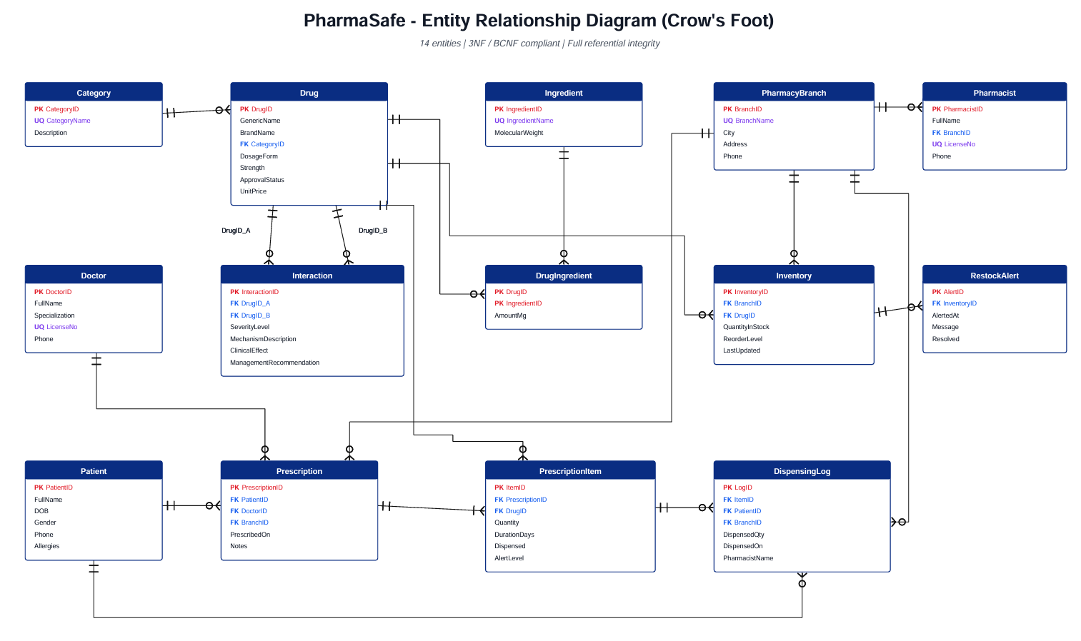

2.2 The 13 entities, briefly
Most of these are obvious from their names, but there are a few choices that probably need explaining:
- Drug stores the master record for a medicine — generic name, brand name, strength, form, category, price.
- Ingredient and DrugIngredient handle the many-to-many between drugs and active ingredients. We kept this even though we did not heavily use ingredient-level interaction checking, because it makes the schema future-proof.
- Interaction is a self-referencing many-to-many on Drug. Each row says "DrugID_A and DrugID_B together are dangerous, and here is why and how serious." A CHECK constraint stops a drug from interacting with itself.
- Pharmacist was something we added during development. Originally we had a free-text PharmacistName column inside DispensingLog, but that meant we could not check whether a pharmacist actually belonged to a given branch. Adding a proper Pharmacist table fixed that.
- RestockAlert is small but important — Trigger 5 (the inventory after-update trigger) writes into it whenever stock crosses below the reorder threshold. The Inventory Reorder report is built on this idea.
Entity | What it is for | Important constraints
Category | Therapeutic class of drugs | PK CategoryID, UQ CategoryName
Drug | Master catalogue of medicines | PK DrugID, FK CategoryID, UQ(GenericName, Strength, DosageForm)
Ingredient | Active pharmaceutical ingredients | PK, UQ IngredientName
DrugIngredient | M:N bridge between Drug and Ingredient | Composite PK
Interaction | Pairs of drugs known to interact | UQ(DrugID_A, DrugID_B), CHECK A <> B
Doctor | Prescriber records | UQ LicenseNo
Patient | Patient profiles, including allergies | CHECK DOB <= today
PharmacyBranch | Physical pharmacy locations | UQ BranchName
Pharmacist | Staff members tied to a specific branch | FK BranchID, UQ LicenseNo
Prescription | A doctor-written prescription header | FK PatientID, DoctorID, BranchID
PrescriptionItem | One drug line on a prescription | FK PrescriptionID, DrugID, ENUM AlertLevel
Inventory | Per-branch stock counts | UQ(BranchID, DrugID), CHECK QuantityInStock >= 0
DispensingLog | Audit log of every dispense | FK ItemID, PatientID, BranchID
RestockAlert | Auxiliary table populated by Trigger 5 | FK InventoryID

2.3 Normalisation
Every table is in 3NF. We checked this by listing the functional dependencies for each table — every non-key attribute depends only on the primary key, and there are no transitive dependencies of the form A → B → C. Both of our many-to-many relationships are properly resolved into bridge tables (DrugIngredient and Interaction), so there are no repeating groups anywhere.
Interaction is also in BCNF. Its only candidate key is the composite (DrugID_A, DrugID_B), and every other column depends fully on that pair. The same is true of DrugIngredient. We did not encounter any 2NF or 3NF violations during design — having normalisation as a hard requirement from the start meant we did not have to refactor anything later.

2.4 Constraints we put in
We tried to be aggressive with constraints, since a constraint inside the schema is enforced by every connection to the database, not just our forms. The complete list:
- Foreign keys with CASCADE / RESTRICT behaviour spelled out for each relationship.
- CHECK constraints on every numeric column that should never go negative or zero (UnitPrice, Quantity, QuantityInStock, MolecularWeight, AmountMg).
- UNIQUE constraints on drug formulations, branch names, ingredient names, and licence numbers (both pharmacist and doctor).
- ENUM constraints restricting severity levels, alert levels, gender, dosage form, and approval status to a known list of values.
- NOT NULL on every business-critical column.
- A CHECK on Interaction that prevents a drug from being recorded as interacting with itself (DrugID_A <> DrugID_B).
- A CHECK on Patient that prevents a future date of birth.

3. Triggers, Views, and Transactions
We ended up writing 8 triggers in total. Three of them were required by the proposal, and we added five more during development as we kept noticing situations where one more check would help. Below is the full list with a one-line explanation of what each one does.

3.1 The 8 triggers
Trigger | When it fires | What it does
trg_pi_before_insert | BEFORE INSERT on PrescriptionItem | The interaction-severity check. Looks at every other drug the same patient is currently taking, finds matching rows in Interaction, and writes the worst severity into AlertLevel. If severity is Contraindicated and the row is being inserted with Dispensed = TRUE, the trigger blocks it.
trg_pi_check_stock | BEFORE INSERT on PrescriptionItem | Looks up the prescribing branch's stock for that drug. If the prescribed quantity is more than what is in stock, the trigger blocks the prescription with an error.
trg_pi_check_quantity | BEFORE INSERT on PrescriptionItem | Sanity check on prescription quantity itself — must be positive, must be within reasonable bounds. Catches typing errors like 5000 instead of 50.
trg_inventory_after_update | AFTER UPDATE on Inventory | Whenever stock drops below the reorder threshold, this trigger writes a new row into RestockAlert. The Inventory Reorder Report uses this to highlight what needs ordering.
trg_dispensing_after_insert | AFTER INSERT on DispensingLog | After a successful dispense, deducts the dispensed quantity from the right inventory row. This is the trigger that actually moves the inventory numbers.
trg_dispensing_validate_pharmacist | BEFORE INSERT on DispensingLog | Looks up the pharmacist by name in the Pharmacist table and checks that their assigned BranchID matches the BranchID where the dispense is happening.
trg_dispensing_validate_patient | BEFORE INSERT on DispensingLog | Checks that the patient claiming the medicine actually owns the prescription. A different patient cannot collect somebody else's drugs.
trg_dispensing_validate_quantity | BEFORE INSERT on DispensingLog | Adds up everything already dispensed for that prescription item and compares against what the doctor prescribed. Stops over-dispensing across multiple visits.

3.2 The validation chain when a dispense happens
When a pharmacist hits the Dispense button on the Dispensing form, four BEFORE triggers fire in sequence on the DispensingLog row, and one AFTER trigger fires once the row is committed. The order is:
- Pharmacist must work at the dispensing branch (trg_dispensing_validate_pharmacist).
- Patient claiming the drug must own the prescription (trg_dispensing_validate_patient).
- Cumulative dispensed amount must not exceed the doctor's prescribed amount (trg_dispensing_validate_quantity).
- CHECK constraint on Inventory blocks negative stock if the about-to-fire AFTER trigger would underflow it.
- Then trg_dispensing_after_insert fires and deducts inventory.
- If the deduction crosses the reorder threshold, trg_inventory_after_update fires and writes a RestockAlert row.
If any one of these fails, the entire INSERT is rolled back — the dispense was never logged, the inventory was never deducted, and the alert was never written. This is what makes the whole thing safe even though it happens through a half-dozen separate steps.

3.3 The two views
View | What it gives you
ActivePatientMedications | Joins Patient, Prescription, PrescriptionItem, Drug, and Doctor. Filters to prescriptions from the last 90 days. Each row tells you which patient is taking which drug, who prescribed it, and what the alert level is. The analytics dashboard reads from this.
SevereDrugPairs | A pre-filtered list of every Severe and Contraindicated interaction, ordered by severity descending. Useful for clinicians who just want to look up dangerous combinations without writing a query.

3.4 The ACID transaction
We wrote a stored procedure called DispenseItem that wraps the entire dispense workflow in a START TRANSACTION ... COMMIT block, with an EXIT HANDLER FOR SQLEXCEPTION that calls ROLLBACK on any failure. Inside the transaction it: (a) re-reads the AlertLevel under a FOR UPDATE lock so two pharmacists cannot race against each other on the same item, (b) verifies stock availability, (c) inserts the DispensingLog row (which fires all the BEFORE and AFTER triggers we listed), and (d) marks the PrescriptionItem as Dispensed.
If anything in those four steps fails — a contraindication SIGNAL, a CHECK constraint, a trigger SIGNAL, an FK violation — the EXIT HANDLER rolls everything back atomically. This is the standard ACID pattern: either every step happens or none of them happen, and the database is never left in a partial state where the dispense was logged but the inventory was not deducted.

4. Queries and Reports

4.1 The six queries
We built six queries to demonstrate the SQL techniques the course covered — multi-table joins, GROUP BY with ROLLUP, correlated sub-queries, aggregates with computed percentages, and so on. Each query is saved as a .sql file in the project bundle, so they can be re-run on any seeded database without modification.
# | Title | What is interesting about it
Q1 | Full Prescription Print | A 5-table join (Patient, Doctor, Prescription, PrescriptionItem, Drug) plus a LEFT JOIN to the Interaction view to attach severity info if any pair on the prescription is dangerous.
Q2 | Dangerous Combo Rankings | GROUP BY drug pair, COUNT how many times each one shows up, filter to Severe or Contraindicated only, ORDER BY count DESC. Tells you which dangerous pair is most commonly co-prescribed.
Q3 | At-Risk Patient List | Correlated EXISTS sub-query joining PrescriptionItem with itself for the same patient, then intersecting against the Interaction table. Returns patients who have at least one bad pair on their record.
Q4 | Dispensing Frequency Report | GROUP BY ... WITH ROLLUP for branch and drug subtotals plus a grand total. Demonstrates the WITH ROLLUP modifier that the course covered.
Q5 | Inventory Reorder Report | WHERE filter on stock < reorder, joined with Drug and PharmacyBranch. This is what the MS Access grouped Report uses as its data source.
Q6 | Doctor Prescribing Patterns | GROUP BY DoctorID, COUNT DISTINCT prescriptions, plus a computed percentage of high-severity prescriptions. Lets administrators identify doctors whose prescribing patterns may need review.

4.2 The Inventory Reorder Report
We built one MS Access report — rptInventoryReorder. It runs the Q5 query as its data source and uses the Access grouping wizard to organise items by BranchName. Inside each branch, items are sorted by deficit descending. There is also a Status column that uses an IIf expression to tag items as URGENT or Order soon depending on how big the gap is, and conditional formatting paints URGENT rows in red.
Subtotals at each branch break show the total deficit for that pharmacy plus a percentage of the system-wide deficit. A grand total at the bottom of the report sums everything up. This is the kind of report a regional pharmacy chain manager would actually want on their desk every Monday morning.
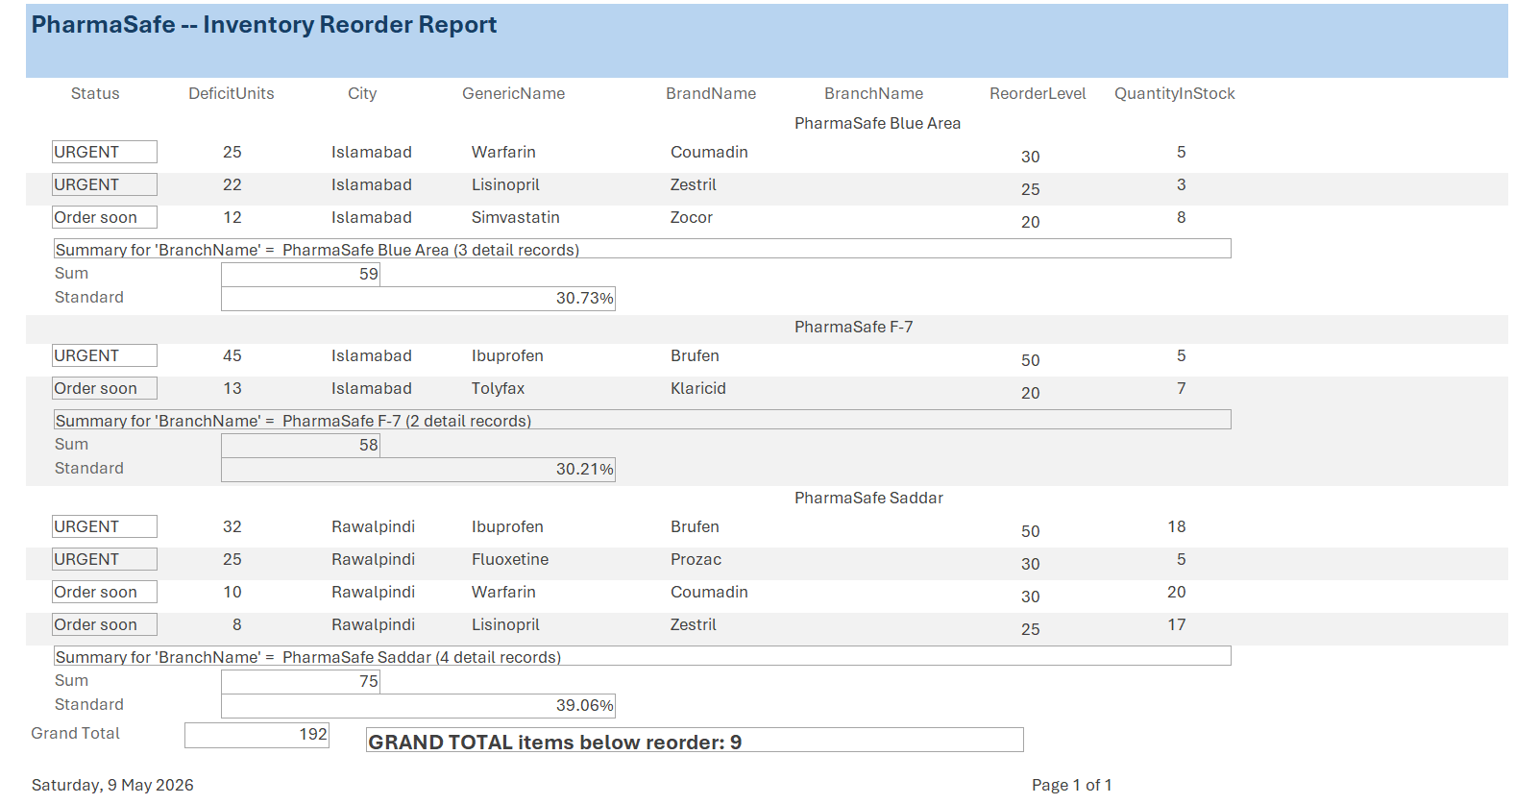

5. The MS Access Forms
We built four forms covering the full workflow. The forms talk to MySQL through the MySQL Connector/ODBC 8.0 driver, which means changes saved in Access are persisted to MySQL in real time and the triggers fire immediately. Whenever a trigger raises an error, Access shows it as a popup with the SQL message text.

5.1 Drug Entry
This is the simplest form. The pharmacy administrator uses it to add new drugs to the catalogue or update existing ones. CategoryID is a combo box pulling from the Category table; DosageForm and ApprovalStatus are combos backed by ENUM value lists; UnitPrice has a CHECK constraint preventing negative values. DrugID is auto-generated by MySQL, so we made it locked on the form.
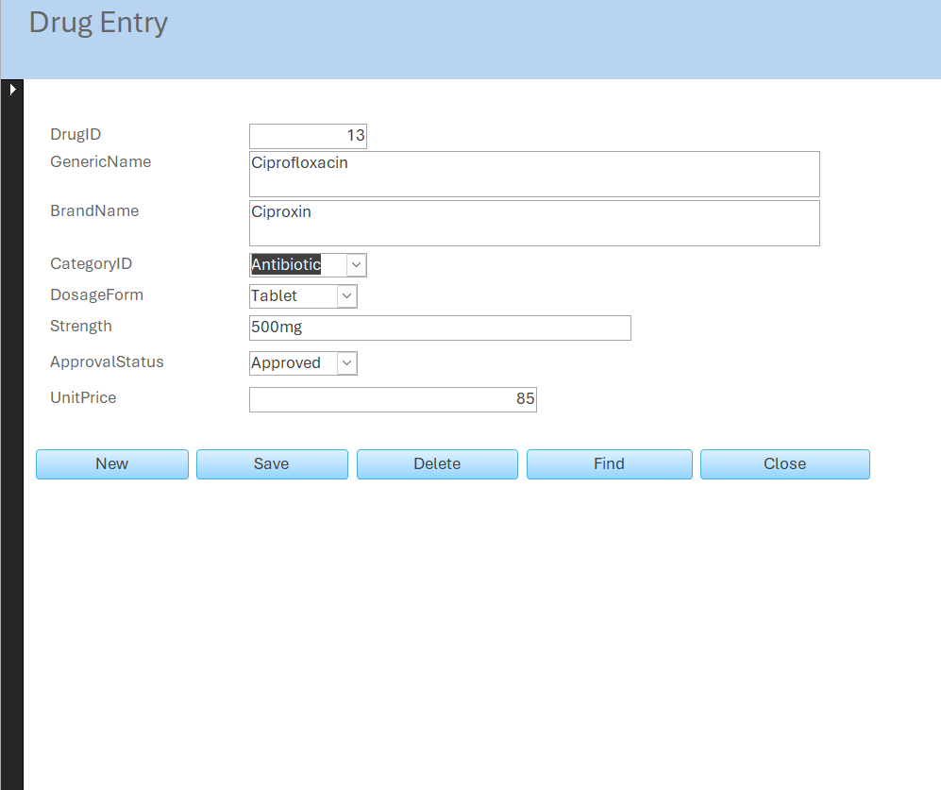

5.2 Prescription
This is the busiest form. The parent area captures patient, doctor, branch, prescription date, and free-text notes. All three of the FK fields are combo boxes pulling from their master tables, with multiple visible columns so the doctor sees patient names instead of raw IDs.
The interesting thing is the embedded subform underneath, which is named prescriptionitem and shows in datasheet view. Each row in the subform is one drug line on the prescription. When the doctor adds a row and tabs to the next field, the trigger trg_pi_before_insert fires in MySQL and writes the appropriate AlertLevel back into that row. Pressing F5 in Access requeries the recordset and the AlertLevel becomes visible. We also set up conditional formatting on the AlertLevel column so that Contraindicated rows turn red, Severe turns orange, and Moderate turns yellow.
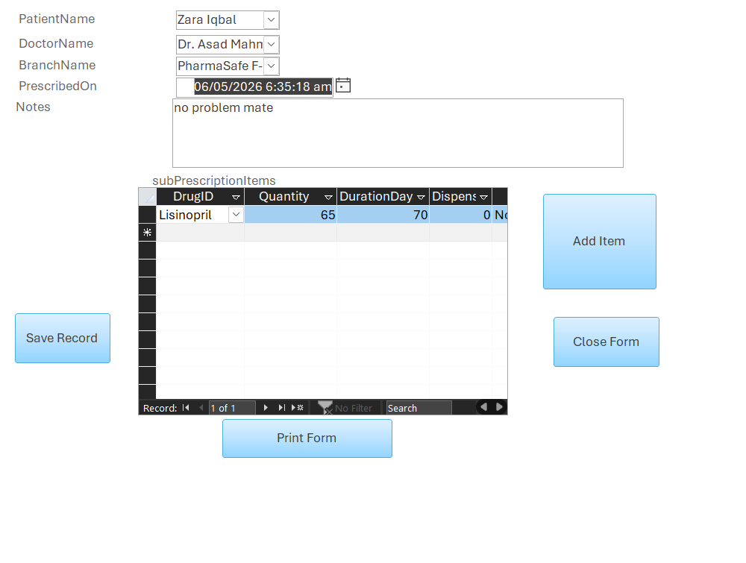

5.3 prescriptionitem (the embedded subform)
Embedded inside Prescription as a datasheet subform, linked by PrescriptionID. This is technically a separate Access form, even though it lives inside another one. Its fields are DrugID (combo box pulling from drug, showing GenericName + BrandName + Strength), Quantity, DurationDays, Dispensed (checkbox), and AlertLevel (locked, set by the trigger).
Because it is in datasheet view, the doctor can add multiple drug lines to a prescription quickly without leaving the main form, and when they save it the parent and child are kept in sync automatically by Access.
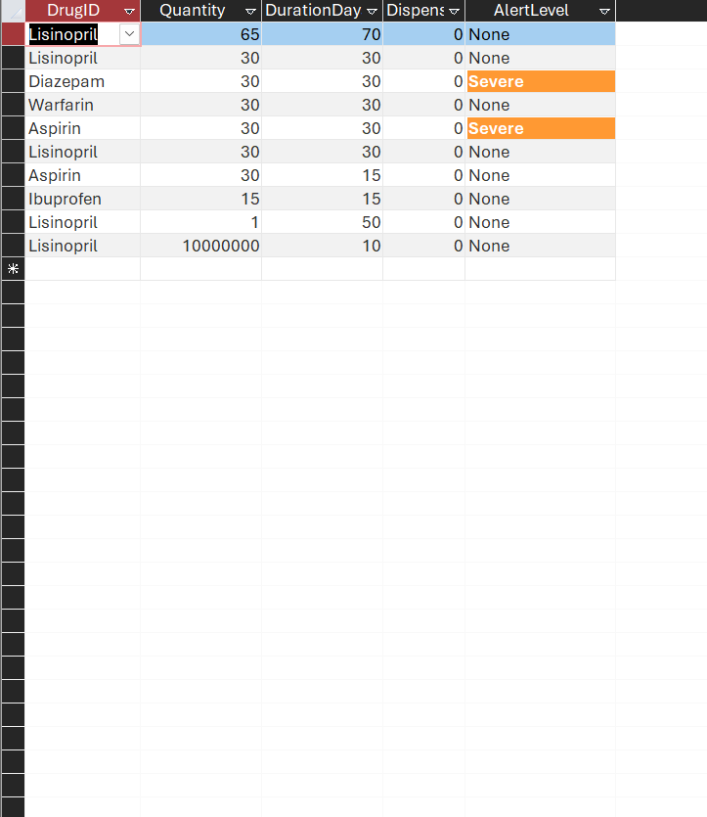

5.4 Dispensing
We are most proud of this form. It demonstrates several Access tricks at once:
- Cascading combos. When the pharmacist picks a patient, the ItemID dropdown is automatically narrowed by an After Update macro (Requery on the ItemID combo) so it only shows that patient's prescribed drugs. They cannot accidentally pick somebody else's prescription.
- Auto-fill DispensedQty. When the pharmacist picks the item, a SetValue macro on the ItemID combo's After Update fills DispensedQty with the prescribed quantity using [ItemID].[Column](2). The pharmacist does not have to type it.
- Locked DispensedQty. We set Locked = Yes and Tab Stop = No on DispensedQty so the pharmacist must dispense exactly what was prescribed. They cannot reduce or increase it from the form.
- Save & Next button. A custom button that runs SaveRecord followed by GoToRecord New, so the pharmacist can dispense multiple items for the same patient in one go without losing context.
When the pharmacist clicks Dispense, three BEFORE INSERT triggers fire: pharmacist branch match, patient match, and prescribed-quantity limit. Any rejection bubbles up as an ODBC error popup. On success, trg_dispensing_after_insert fires and updates inventory automatically.

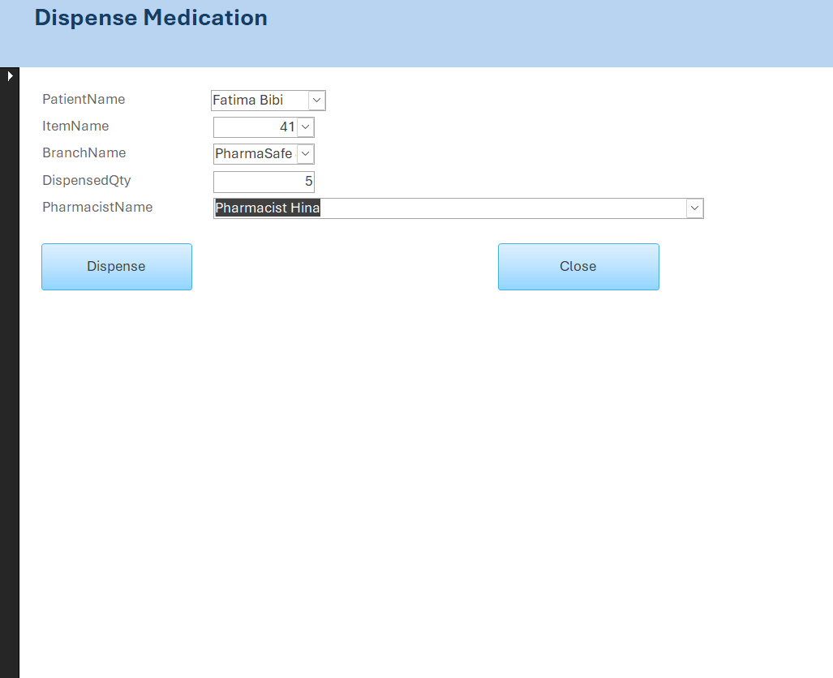

6. The Two End-to-End Workflows
Once we had the schema, the triggers, and the forms in place, the system's behaviour came down to two main user journeys. Both of them rely entirely on the trigger chain to keep the data consistent — there is no Access-side coordination code, just the trigger network in MySQL.

6.1 Prescribing
- Doctor opens the Prescription form and selects patient, doctor, and branch.
- They press Tab to commit the parent row and move into the prescriptionitem subform.
- They pick a drug from the combo box and type a quantity and a duration.
- Access sends an INSERT statement to MySQL through ODBC.
- trg_pi_check_stock fires first — it looks up the prescribing branch's stock and rejects the row if the prescribed quantity exceeds what is available.
- trg_pi_check_quantity fires — it sanity-checks the quantity itself.
- trg_pi_before_insert fires — it computes the AlertLevel based on the patient's other current drugs.
- If AlertLevel is Contraindicated and the row tries to insert with Dispensed = TRUE, the trigger raises SIGNAL and the INSERT is rolled back.
- Otherwise, the row commits. Pressing F5 refreshes the subform and the AlertLevel shows up coloured (red / orange / yellow / green).

6.2 Dispensing
- Pharmacist opens the Dispensing form and picks a patient.
- The After Update macro on the patient combo requeries the ItemID combo. Now its dropdown only shows that patient's prescribed drugs.
- Pharmacist picks an item from the narrowed dropdown. The SetValue macro on the ItemID combo's After Update fills in DispensedQty automatically with the prescribed amount.
- Pharmacist picks a branch and a pharmacist name from the respective combos.
- They click Dispense, which is wired to a SaveRecord macro.
- Three BEFORE INSERT triggers fire: pharmacist must work at this branch, patient must own this prescription, and total dispensed across visits must not exceed prescribed.
- Any rejection becomes an ODBC popup error in Access, and the row never commits.
- On success, trg_dispensing_after_insert fires and deducts the inventory.
- If the deduction crosses below ReorderLevel, trg_inventory_after_update fires and writes a row into RestockAlert. The next time the Inventory Reorder report runs, that drug at that branch will appear on it.
- Pharmacist clicks Save & Next to dispense the next drug for the same patient.

7. Analytics Dashboard (bonus #2)
We wrote a Python script (analytics_dashboard.py) that connects to MySQL using the mysql-connector-python driver and produces two charts via matplotlib. The first is a horizontal bar chart of the top 10 most-dispensed drugs by total quantity, computed from a GROUP BY query over DispensingLog joined with PrescriptionItem and Drug. The second is a donut pie chart showing the distribution of interaction severity levels across the Interaction table.
We also generate a single combined dashboard PNG that shows both charts side-by-side, so it is easy to drop into reports or presentations:
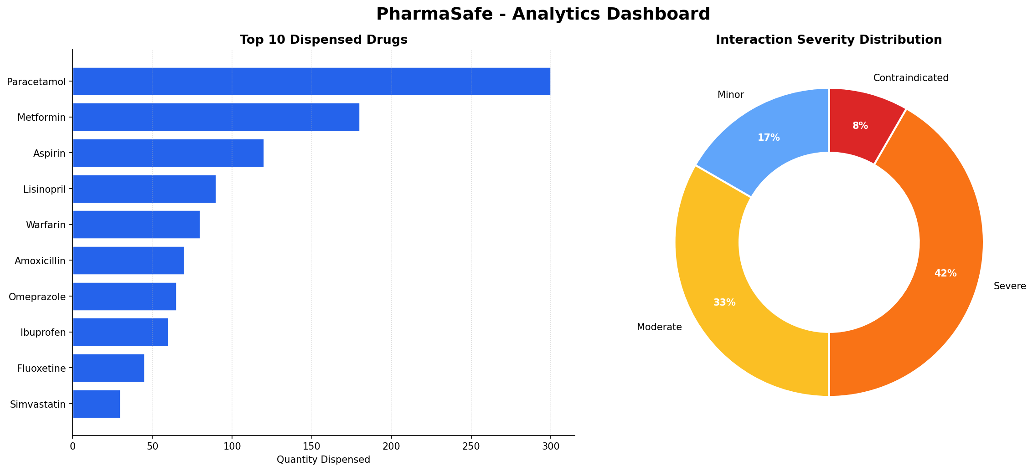
If MySQL is not reachable for any reason — say, the demo machine has its services stopped — the script falls back to a small synthetic dataset so it still produces output. We thought of this as a defensive feature, since we did not want a broken connection to ruin a presentation.

8. ETL Pipeline (bonus #1)
The etl_pipeline.py script handles the kind of data ingestion you would actually need in production. The dataset we used is a CSV based on the DrugBank Open Data and FDA structured product label format, with one row per drug pair and columns for severity, mechanism, clinical effect, and management recommendation.
The pipeline does the following four steps:
- Extract: pandas reads the CSV.
- Transform: trim whitespace from text columns, normalise severity casing to title case, drop rows with severity values outside our controlled vocabulary, remove self-pairs (drug A = drug B), deduplicate (A,B) ↔ (B,A) pairs by sorting names alphabetically before comparison.
- Resolve: the CSV gives us drug names as strings. We join them against the Drug table to look up DrugIDs. Any names we cannot resolve are logged to a separate file and skipped.
- Load: we write the cleaned data to a staging CSV and then bulk-load it via LOAD DATA LOCAL INFILE for maximum throughput. If LOCAL INFILE is disabled on the server, the script falls back to row-by-row INSERTs.
We deliberately wrote the pipeline to be idempotent — running it again clears the Interaction table first and re-loads from scratch. This was important for development because we wanted to be able to refresh the data without worrying about leftover rows from earlier runs.

9. The Full Safety Matrix
Every safety rule we built is enforced inside the database — not in any application or form. The list below is what the database itself refuses to do. If you connected to MySQL through the command line, MySQL Workbench, or any third-party tool, you would hit exactly the same rules.
Rule | How it is enforced
Drug-drug interaction detection | trg_pi_before_insert sets AlertLevel automatically.
Block contraindicated dispensing | trg_pi_before_insert raises SIGNAL when AlertLevel = Contraindicated AND Dispensed = TRUE.
Cannot prescribe more than is in stock | trg_pi_check_stock blocks the insert with an error.
Prescription quantity must be sane | trg_pi_check_quantity rejects extreme values.
Pharmacist must work at the dispensing branch | trg_dispensing_validate_pharmacist rejects mismatches.
Patient must own the prescription (HIPAA-style) | trg_dispensing_validate_patient rejects identity mismatches.
Cumulative dispense cannot exceed prescribed | trg_dispensing_validate_quantity sums prior dispenses and compares.
Stock cannot go negative | CHECK (QuantityInStock >= 0) on Inventory blocks underflow.
Quantities must be positive | CHECK constraints on every quantity field.
No self-interactions | CHECK (DrugID_A <> DrugID_B) on Interaction.
Patient DOB cannot be in the future | CHECK (DOB <= CURRENT_DATE) on Patient.
Drug names are unique by formulation | UNIQUE(GenericName, Strength, DosageForm) on Drug.
Pharmacist licences are unique | UNIQUE(LicenseNo) on Pharmacist and Doctor.

10. What We Took Away From This
Building PharmaSafe taught us three things we did not really understand from lectures alone.
First, schema design pays off. We wasted no time on schema migrations during development because we got the entities right at the start. Whenever we added a new feature, like the Pharmacist table, it slotted in cleanly because the rest of the schema was already coherent. We can see why companies treat database design as a serious upfront investment.
Second, triggers are powerful but you have to be careful about ordering. We had a few bugs early on where two BEFORE INSERT triggers were both inspecting the same row, and we did not initially realise the order they fired in mattered. Once we worked out the dependency chain, the system became much easier to reason about. The rule we settled on was: validation triggers first (the BEFORE ones), action triggers second (the AFTER ones), and never put two action triggers in a chain that depended on each other's output.
Third, MS Access and MySQL are a surprisingly good pairing for a project like this. Access gave us forms and reports almost for free, and the ODBC linked tables meant our triggers fired exactly the same way whether we were using the Access form or running SQL directly in phpMyAdmin. We did hit a few quirks — Access SQL is stricter than MySQL about parentheses around joins, MariaDB has issues with DECLARE'd variables in WHERE clauses — but none of them were dealbreakers. We learned how to spot the warnings and rewrite the SQL accordingly.
More than anything, the project showed us why a database can be more than just a table store. With triggers, views, transactions, and well-designed constraints, the database becomes the system's rule book. Application code can come and go but the rules stay. This idea seems obvious in hindsight but we had not really internalised it before.

10.1 Acknowledgements
Drug data, interaction pairs, and clinical effect descriptions are based on publicly available references from DrugBank Open Data and FDA structured product labels. All patient, doctor, and pharmacist records in the demo data are synthetic. Any resemblance to real people is unintentional.
Submitted by Muhammad Shazil Khan

